They creep, they crawl, they kill
The first time I removed a tick from my dog was a huge production: nitrile gloves, tweezers, bleach, hot water, dish soap, another set of tweezers, paper towels, a sealed plastic baggie. Now I casually pluck off ticks while eating cereal in the morning. Somewhere between these two extremes is how we should view these disease-laden creatures.
Despite being like mosquitoes and fleas in that they need a blood meal to survive, ticks are not actually insects. They are related to spiders and mites which are arachnids. Around the world, there are over 850 distinct species of tick which are categorized into hard ticks and soft ticks. Hard ticks have a shield-like plate which covers part of its back.
Ticks can carry more diseases than any other arthropod in the world. Diseases transmitted by ticks include Rocky Mountain spotted fever (RMSF), Colorado tick fever, and tularemia. RMSF is a bacterium which is spread by the American dog tick, the Rocky Mountain wood tick, and the lone-star tick. Despite the name of the disease, most cases are contracted in the southeast U.S. Colorado tick fever is limited to the western U.S. and prevalent from March thru August and can be transmitted by the Rocky Mountain dog tick. Tularemia is most common in rural areas as several species of tick as well as rodent carcasses, flies, contaminated food/water, and infected aerosols can be sources.
The tick’s ability to vector these diseases is very high since some species prefer three different host species in order to complete its life cycle. The four life-stages of a tick are the egg, six-legged larva, eight-legged nymph, and adult. All stages except the egg stage require a blood meal so some tick species may take up to three years to complete their life cycle if distinct host species are required.
The term “questing” is used to describe actions ticks take in order to find a host. Ticks will crawl up vegetation and hold their two front sets of legs outward while grasping the vegetation with their two back sets of legs. Attracted to colors, odors, carbon dioxide, and other indicators, ticks can even find commonly used paths to wait for animals to brush against the vegetation. Larva quest closer to the ground while nymphs and adults are able to quest on higher vegetation. After initial contact with their host, the tick may take several hours to attach in search for the ideal feeding location. Once ready to attach, the tick will make an incision into the skin and insert a feeding tube. Several species can inject a substance which acts like cement to hold them in place during feeding. Additionally, barbs on the feeding tube help keep the tick in place.
Be aware of ticks from early spring until mid-July especially in tall, grassy vegetation, wooded areas, when raking and carrying leaves, and moving firewood. Many home-remedies and wives’ tales exist to remove a tick which has attached to the host. Unfortunately, most of these methods might make the potential to contract a disease worse. Applying rubbing alcohol, petroleum jelly, nail polish remover, or a lit match may cause the tick to release additional saliva into the host therefore increasing the chance of infective material being introduced.
The recommended way to remove a tick is to use fine-tipped tweezers to grasp the tick as close to the skin surface as possible and then pull upward with steady, even pressure. After removal, the skin should be cleaned and disinfected. Disposal of the tick is very important. Ticks can survive in water for weeks so it is not recommended to flush them down the toilet or sink. Stepping on or smashing a tick can release toxins which can also transmit disease. The best way to dispose of a tick is submersing it in rubbing alcohol in a sealable bag or container and then throwing away the entire container. However, if the tick has been attached for several hours it may be worthwhile to save the tick if identification is necessary for proper diagnosis of a transmitted disease.
Thankfully, there are several ways to prevent tick bites. Wearing light-colored clothing will allow for easier spotting of ticks on clothing. To keep ticks from climbing on the inside of pants and shirts, tuck pant legs into socks and shirts into pants. Repellants containing DEET or picaridin can be sprayed on clothing. Pets can be protected using various products including monthly treatments and daily-use collars. For more information, contact your local weed and pest control office or Goshen County Weed and Pest at: (307) 532-3713, gocoweeds@embarqmail.com, or https://www.facebook.com/gocoweeds.

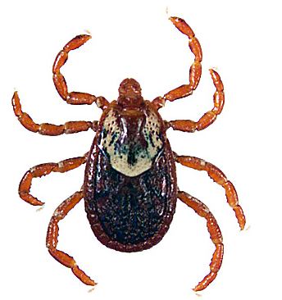
Rocky Mountain Wood tick, adult female

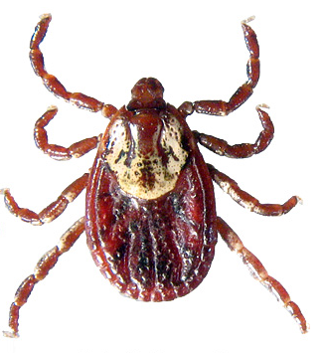
American Dog tick, adult female

Photos from tickencounter.org

